AI STUDY BUDDY API - Project Explanation
TEAM LEADER | DIVYA B
EMAIL ID | sac2427bca5339@collegechennai.com
TEAM MEMBER | BHUVANESHWARI V
EMAIL ID | sac2427bca5349@ssacollegechennai.com
TEAM MEMBER | ASHWITHA PENNITA RANI J
EMAIL ID | sac2427bca5233@ssacollegechennai.com
TEAM MEMBER | BATHURNISHA H
EMAIL ID | sac2427bca5282@ssacollegechennai.com
1. Introduction
AI Study Buddy API is an artificial intelligence-based system designed to help
students in their learning process. It provides study assistance, answers
questions, summarizes study materials, and helps students understand difficult
topics.
The API allows students to interact with an AI-powered study assistant and
receive quick and useful learning support.
2. Objectives
●To provide instant answers to students' academic questions.
●To simplify difficult concepts using AI.
●To generate summaries of study materials.
●To support effective and personalized learning.
●To save students' time and improve their understanding.

3. Existing System
In the existing system, students mainly depend on textbooks, teachers, and
online resources to clarify their doubts. Finding relevant information from different
sources can take more time.
Traditional learning methods may not always provide immediate answers or
personalized explanations for every student.
4. Proposed System
The proposed AI Study Buddy API uses artificial intelligence to provide an
interactive learning experience. Students can submit questions or study materials
through the system and receive relevant responses.
The system supports question answering, content summarization, and simple
explanations, making learning easier and more accessible.
5. System Requirements
Hardware Requirements
●Computer or laptop
●Minimum 4 GB RAM
●Internet connection
Software Requirements
●Operating System: Windows
●Programming Language: Python
●API Framework: Flask or FastAPI
●AI Model API for generating responses
●Web browser or API testing tool
6. System Modules
1. Question Answering Module: Accepts student questions and generates
relevant answers using AI.

2. Study Material Summarization: Converts lengthy study materials into short and
meaningful summaries.
3. Concept Explanation: Explains complex academic topics in simple and
understandable language.
4. API Response Module: Processes requests and returns AI-generated
responses in a structured format.
7. System Working
The system works through the following steps:
1. The student enters a question or study material.
2. The API receives the request from the user.
3. The AI model processes the given input.
4. The system generates an appropriate response.
5. The API sends the response back to the student.
8. Advantages
●Provides quick academic assistance.
●Makes difficult topics easier to understand.
●Reduces time spent searching for information.
●Supports self-learning and revision.
●Can be integrated into websites and educational applications.

9. Applications
●Online learning platforms
●College and school education
●Exam preparation and revision
●Personal study assistance
●Educational mobile and web applications
10. Conclusion
The AI Study Buddy API provides an effective way to support students through
artificial intelligence. It helps students clarify doubts, summarize study materials,
and understand academic concepts easily. This system can be further developed
with additional features such as personalized study plans and progress tracking
to improve the learning experience.

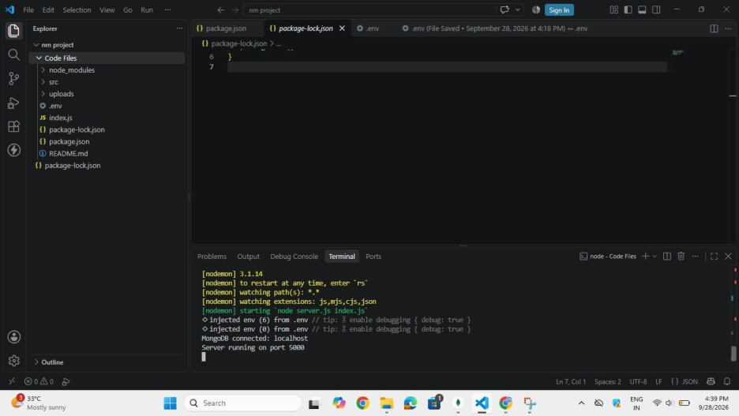

SCREEN SHORTS:

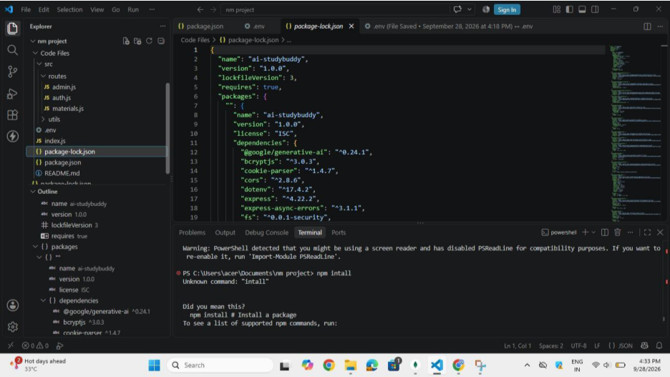

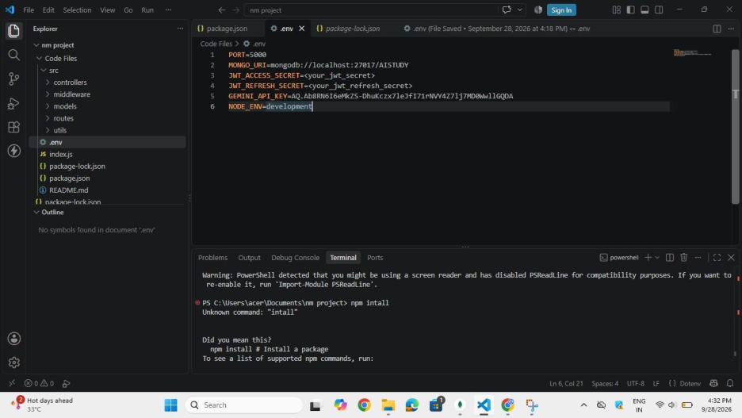

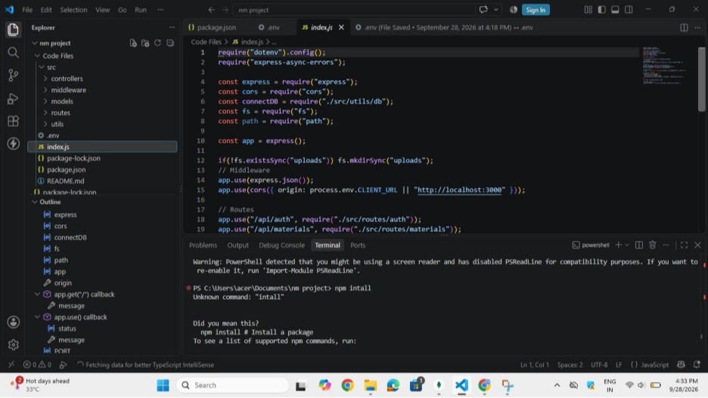

API Testing Link: https://drive.google.com/file/d/19txrOFNbhNA2xLt3WXsITH-
gwWYSl950/view?usp=drive_link
Demo Video Link: https://drive.google.com/file/d/19txrOFNbhNA2xLt3WXsITH-
gwWYSl950/view?usp=drive_link
Code Drive Link:
https://drive.google.com/drive/folders/1mfJrGr63VDaF4zhXO7j9DIS_EWGJWjK0

